Design Document and Test Plan

Name of team members who collaborated on the design and test plan:

1. Name (*first last*): __Reeves Farrell_________________
2. Name (*first last*): ___________________
3. Name (*first last*): ___________________

Name of programming challenge for which you submit this document: __Areas Calculation_________________

# Pseudocode

*(See Ch. 1.6, p. 20 in our textbook for an example of how to write detailed pseudocode)*

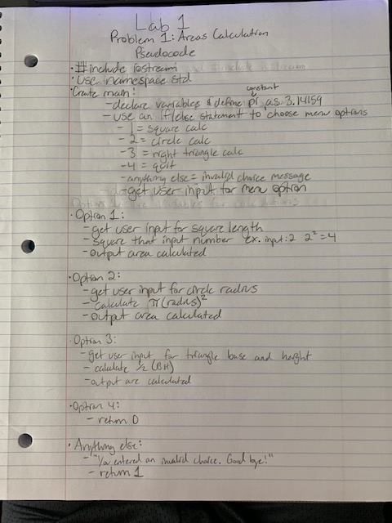 Update: also include iomanip

# Test Plan

*(See Ch. 5.13, p. 306 in our textbook for an example of how to write a test plan)*

|  |  |  |  |
| --- | --- | --- | --- |
| **Test #** | **Purpose** | **Input** | **Expected Output** |
| 1 | Makes sure square calculation works | 1  Length: 2 | Area = 4.00 |
| 2 | Makes sure circle calculation works | 2  Radius: 3.0 | Area = 28.27 |
| 3 | Makes sure right triangle calculation works | 3  Base: 4  Height: 6 | Area = 12 |
| 4 | Makes sure quit button works | 4 | The program should quit without doing anything |
| 5 | Test to see if pressing a different key outputs the invalid choice message | Any key other than 1, 2, 3, or 4 | You have entered an invalid choice. Good bye! |
| … | *(Feel free to add more test cases)* |  |  |